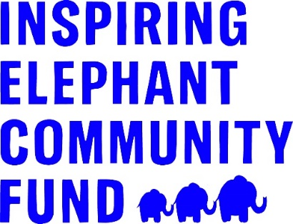

Programme Guidelines 2026

The Inspiring Elephant Community Fund opened in 2022 to support the local community of Elephant and Castle over the next five years. To achieve this, the fund distributes £50,000 annually in grants to charities that support the community in and around The Elephant town centre. These grants help to fund both short term projects and sustain long-term support for the community.

The aim of the Fund is to deliver greater social value for residents and for the local community to be engaged in the process. Therefore, we share details about fund applications with relevant stakeholders and partners and use a panel of local community leaders to consider applications. The panel comprises members of the Community Hub and representatives from Get Living and Southwark Council.

The Inspiring Elephant Community Fund builds on the support The Elephant town centre team and Get Living have provided to the local community over the last few years. To date, this support has included £300,000 of donations distributed to local groups, such as Shakespeare’s Globe, Evelina London Children’s hospital through the National Portrait Gallery’s Hospitals Programme and the Prince’s Trust. Additionally, the Elephant and Castle Community Hub provides free activities to locals on a weekly basis, both online and in-person across different venues in the area. Since 2022, the Inspiring Elephant Community Fund has awarded £200,000 to 44 community projects to support residents through arts activities, wellness sessions, training opportunities and more.

Available Funding
This is the final year of the Inspiring Elephant Community Fund. This year the fund will focus on two priority areas of Public Art, and Skills & Employment for Young People.

The total value of the Inspiring Elephant Community Fund is £50,000 per year. It is anticipated the funding will be equally split between the two priority areas. This will be dependent on quality of applications received, and the Inspiring Elephant Grants Panel may award more grants to one or other of the priority areas.

Organisations can apply for a grant of up to £7,000 to deliver community activities supporting residents as outlined in the Priorities below and taking place in and around the Elephant & Castle Opportunity area (see more details below).

Timeline for applications and awards
This grant programme is open to applications for 7 weeks from 5th January 2026 to 23rd February 2026.

Funding will be awarded in April 2026. Project delivery timelines for each priority area are set out below.

The Elephant and Castle Community Hub: The Elephant and Castle Community Hub is located in Castle Square, 2nd floor, 40 Elephant Rd, London SE17 1EU. Applicants can apply to run proposed projects from this space. If you are interested in running your project from this venue, please indicate this in the application form along with another venue option, in case the hub cannot be secured for your project.

Priorities
Grants are available to support a variety of projects and activities taking place in and around The Elephant town centre – within the Elephant & Castle Opportunity Area - under one of three priority areas. It’s important to read through the guidelines fully to make sure you are selecting the right theme, and there is a clear connection between the outcomes of your project and the theme priorities.

The two priorities are:

- Skills and Employment for Young Adults
- Community Art

Applications should focus on one of these priority areas, the criteria under each are outlined below.

The Elephant team at Get Living would like to support organisations that can demonstrate appropriate links or networks in the local area to deliver the proposal and we welcome the involvement of volunteers within projects and services.

Get Living would like to support a variety of activities that reach a wide community audience of different demographics and minority ethnic groups, people with disabilities, learning disabled people, Travelers, LGBTQIA+ residents, children and young people, older people and people with mental health issues or long-term health issues.

Skills and Employment for Young People
There is an ambition to provide over 200 Southwark residents with a job in the new town centre. To achieve this, we will be working with new tenants and retailers to promote opportunities and employment of residents. We also recognise the need to provide some skills workshops to support residents and enable them to successfully apply, secure and maintain employment opportunities.
This fund will support projects that provide employment and skills development activities for young people, aged 16+, developing capabilities to move into sustainable employment. Activities can include:

- key capabilities and life skills to better prepare them for the world of work, such as confidence, resilience, self-esteem, and mental health
- employability skills and awareness of employment opportunities through production of CVs, application forms, and interview skills
- training and attainment of vocational qualifications, e.g. customer service, food hygiene, security industry authority
- mentoring through quality and trained mentorship initiatives
- work placements, providing hand-on experience
- engagement with employers to promote opportunities directly with residents

The fund will prioritise groups that can demonstrate good local engagement and a track record of successfully delivering skills and employment project. Applicants should highlight this within their application. We will also prioritise projects that are focused on securing employment outcomes.

Project delivery can commence from May 2026 with projects completing by December 2026.

Community Art

The Elephant town centre’s strategy aims to celebrate the local area’s layered identities through art that reflects its past, energises its present, and shapes its shared future. The strategy considers how artworks, heritage storytelling, and partnerships engage local communities, strengthen partnerships, support fair artist selection processes, and ensure the development feels authentic, inclusive, and welcoming. It aims to embed community co-authorship and participation, showcase local artistic excellence, and create a legacy of joy, belonging, and cultural visibility.
This year, the fund wants to support the production of art and/or accompanying resources that will leave a legacy within The Elephant town centre. These could include Permanent Landmark Works that define features of major public spaces, Community-Led and Temporary Installations, or Digital and Experimental Works using light, sound, and motion. This is not a prescriptive list, and the fund is keen to promote innovative approaches.
Projects engaging local communities in the development and creation of projects and art will be prioritised.
There are three themes:
Theme 1: Abstract Soundscape – Rhythm and Flow
Elephant and Castle’s identity has long been shaped by sound — from Latin rhythms and club culture to spoken word and street performance. This theme invites artists to translate movement, rhythm, and sound into visual and spatial form, creating energy and flow across the site. Projects could capture movement, rhythm, or flow in a way that is accessible to a wide audience, acknowledge Elephant’s musical and cultural legacies e.g. Corsica Studios, salsa heritage. We’re also keen to see work that is bold, contemporary and future facing, with the potential to resonate with and represent the 20–39-year-old youth/adult cohort in the local population.
Theme 2: Mapping Identity – Here We Are
Elephant and Castle is a landscape of change and memory. This theme explores how identity is mapped across its shifting architecture, lost landmarks, and evolving communities. Projects are encouraged to reveal unseen geographies, local histories, and the layered character of the place. Initiatives may consider Elephant & Castle as a place with layered geographies and shifting identities, incorporating local narratives and lost landmarks, e.g. Heygate Estate, Shopping Centre, migrant journeys, everyday routes, memory and loss.
Theme 3: People, Diversity, and Stories – Everyday Belonging
This theme celebrates the people of Elephant and Castle — their creativity, resilience, and cultural expression. It invites works that make space for underrepresented voices and highlight the ways communities forge connection and pride in everyday life. Projects should consider celebrating the diversity, resilience, and creativity of Elephant’s communities, making space for invisible community voices, particularly those underrepresented in census data, e.g. Latin Americans, ensuring inclusion through imagery, stories, or engagement, and fostering connection, recognition, and pride among residents of all ages, and across different community groups.
Project delivery should commence from May 2026 with projects completed with production of artwork and/or resources in July 2026 or soon after.

Eligibility
To be eligible to apply to the Community Fund organisations must meet the following points:

- Be a not-for-profit organisation that is formally constituted (have a signed governing document in the organisation’s name). This includes unincorporated associations and community groups, registered charities, social enterprises, schools, Community Interest Companies (CIC) limited by guarantee, Charitable Incorporated Organisations (CIO), companies limited by guarantee and faith groups where the project clearly does not promote a particular religious or political view.
- Have good financial management procedures, including a record of income and expenditure. Applications from organisations that have a financial deficit will be contacted and more details may be requested from the applicant.
- Have a bank account set up in the organisation’s name, with at least two unrelated cheque signatories.
- Delivering activities that either take place within the Elephant & Castle Opportunity Area, or activities that directly benefit people who live, work or study in the area (please see below map)
- Be connected with and meeting the needs of the local community in and around The Elephant town centre – specifically the Elephant and Castle Opportunity Area

If you are an un-constituted voluntary group (such as a group of local residents), you will need to identify a constituted organisation to act as your accountable body or ‘parent organisation’. For example, this could be a local charity, constituted TRA or housing association that is willing to accept any grant money on your behalf. The application form must be completed by the un-constituted group and you must have agreement from the parent organisation confirming they can support you. Please contact Diana on diana.barranco@getliving.com if you would like some help in establishing a ‘parent’ organisation to accept the funds on your behalf.

If you are a creative practitioner or collective, you will need to work with a registered organisation or community group who can receive and administer the grant on your behalf. As we cannot accept applications from individuals, the application form must be completed by the host organisation. Please contact Diana on diana.barranco@getliving.com if you have any questions.

Elephant & Castle Opportunity Area

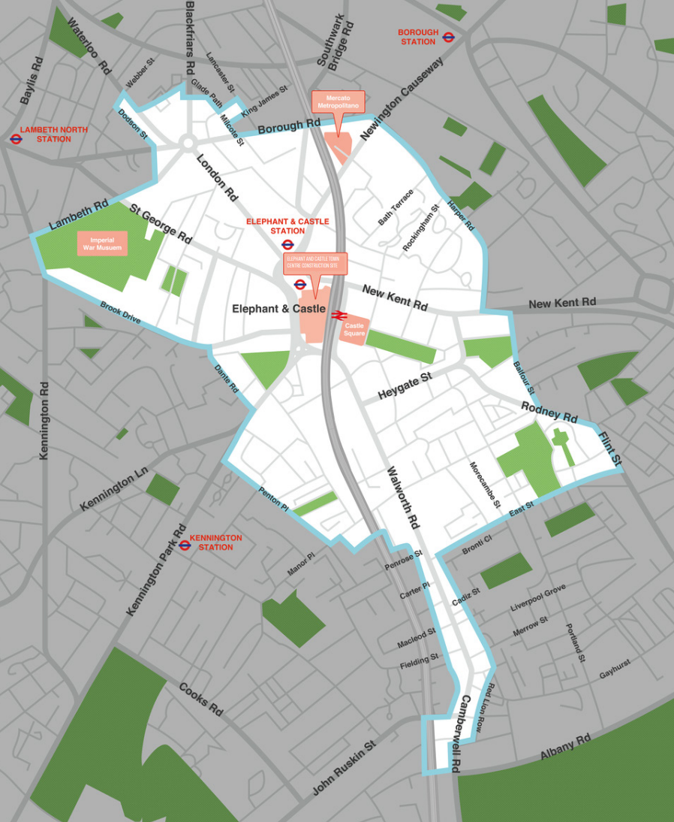

Supporting Documents
To support your application, you must attach relevant documents to your online application. Alternatively, you can also send these documents by email to diana.barranco@getliving.com.

Please ensure you have the following documents ready to attach to your online application:
- Constitution or articles of association (the governing document of your organisation)
- Annual accounts or a record of income and expenditure for the applicant organisation for the most recent financial year
- One bank statement dated within the last 3 months in the organisation’s name that shows the account name, sort code and account number
- Safeguarding Policy for vulnerable adults and/or children and young people
- Equality & Diversity Policy*

* Get Living is committed to equality and diversity for all, and we expect groups and organisations applying for grants to show that they are aware of equality and diversity and can demonstrate commitment to them. Accordingly, organisations applying for grants are required to submit their Equality and Diversity policy with their application.

What We Will Fund
You can apply for funding to cover project activities and staffing, running costs related to the delivery of the project as well as the purchase of equipment you may need. All budgeted items must relate directly to the delivery of the proposed project.

What We Won’t Fund
The Inspiring Elephant Community Fund will not fund:

- Grants to individuals
- Expenditure or activities that have already taken place
- Services which are a statutory responsibility (i.e. are the responsibility of the Council, Government or Health Authorities)
- Religious or political activities (we are able to fund religious organisations if they are providing benefits for the wider community)
- Projects that have no community or charitable element
- Projects that take place outside of The Elephant town centre area
- Foreign travel

How to Apply
To apply for a grant of up to £7,000 please click here for the online application form

Application deadline: 5pm on Monday 23rd February 2026

Your application must be submitted by the date and time above to be considered.

Accessibility
If you have any questions on the Community Fund or would like support with your application please contact Diana on diana.barranco@getliving.com. Paper application forms (and a version in Microsoft Word) is also available and can be provided on request.

Timetable
The Inspiring Elephant Community Fund is open for applications from Monday 5th January 2026.

You can apply at any time, but you must submit your application by the deadline at 5pm on Monday 23rd February 2026.

We will notify you of the outcome of your application after the grants panel has met to consider all submitted eligible requests. This notification is usually 8 to 10 weeks after the deadline. Therefore, please consider this in your project planning and know that applicants will be notified of funding by end of April 2026.

Grant Review Period
Please expect a potential phone call or email from an Inspiring Elephant Community Fund grant assessor the weeks following the grant deadline (February 2026), who may reach out for further details or clarification on your application prior to the grants panel meeting in April.

Project Monitoring
If your application is successful, you must be able to spend the money and deliver your project within the timeframe set out for each priority. You will be sent an end of grant report template via email 60 days prior to the completion of your project. You can request this report link sooner if you would like to gather your reporting information earlier on.

You will need to keep and provide the following:
- Financial records of how the grant is spent, including receipts and invoices
- Records and evidence of the identified outputs e.g. number of people benefiting, number of sessions, records of attendance etc.
- Records of the identified outcomes e.g. the difference the project has made to participants, participant feedback, staff observations, external reports from partners
- Photographs of the project activities (if appropriate)
- A case story from one participant including quotes of how the project has supported them

These pieces of information above must be submitted with the end of grant report. It is important to also gather information throughout the duration of your activities. The end of grant report will ask questions on your project, so please do consider the following to report back on:

- The activities you carried out with the funding
- Number of direct beneficiaries
- Impact numbers (such as how many people learned new skills, reported increased wellbeing, were connected to an advice service, etc.) that relate to your project, based on the outcomes you identified in your application
- Learnings or challenges experienced throughout project delivery
- Any significant changes from participants and a participant story/quote

Public Art projects will also be expected to deliver their commission and/or resources along with their end of grant reporting from July 2026.
Employability projects will also be expected to deliver and complete their projects by December 2026.

If you have any questions on monitoring requirements on projects awarded funding, please contact Diana at diana.barranco@getliving.com
The contribution of the Inspiring Elephant Community Fund must be acknowledged in any promotional literature or annual report issued on your behalf within twelve months of receiving the grant or any instalment of the grant. We reserve the right to use any photographs or details of the project in any future literature and/or promotion.

