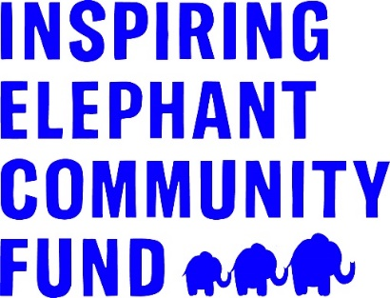

Programme Guidelines 2025

The Inspiring Elephant Community Fund opened in 2022 to support the local community of Elephant and Castle over the next five years. To achieve this, the fund distributes £50,000 annually in grants to charities that support the community in and around Elephant and Castle Town Centre. These grants help to fund both short term projects and sustain long-term support for the community.

The aim of the Fund is to deliver greater social value for residents and for the local community to be engaged in the process. Therefore, we share details about fund applications with relevant stakeholders and partners, and use a panel of local community leaders to consider applications. The panel comprises members of the Community Hub and representatives from Get Living and Southwark Council.

The Inspiring Elephant Community Fund builds on the support the Elephant and Castle Town Centre team and Get Living have provided to the local community over the last few years. To date, this support has included £300,000 of donations distributed to local groups, such as Shakespeare’s Globe, Evelina London Children’s hospital through the National Portrait Gallery’s Hospitals Programme and the Prince’s Trust. Additionally, the Elephant and Castle Community Hub provides free activities to locals on a weekly basis, both online and in-person across different venues in the area. Since 2022, the Inspiring Elephant Community Fund has awarded £150,000 to 39 community projects to support residents through arts activities, wellness sessions, training opportunities and more.

Available Funding
The total value of the Inspiring Elephant Community Fund is £50,000 per year.

Organisations can apply for a grant of up to £5,000 to deliver community activities supporting residents as outlined in the Priorities below and taking place in and around the Elephant & Castle Opportunity area (see more details below).

Timeline for applications and project delivery
This grant programme is open to applications for two months (8-weeks) from 29th January – 27 March 2025.

Funding will be awarded in May 2025 for projects to be delivered between June/July 2025-2026.

The Elephant and Castle Community Hub: The Elephant and Castle Community Hub is located in Castle Square, 2nd floor, 40 Elephant Rd, London SE17 1EU. Applicants can apply to run proposed projects from this space. If you are interested in running your project from this venue, please indicate this in the application form along with another venue option, in case the hub cannot be secured for your project.

Priorities
Grants are available to support a variety of projects and activities taking place in and around the Elephant & Castle Town Centre – within the Elephant & Castle Opportunity Area - under one of three priority areas. It’s important to read through the guidelines fully to make sure you are selecting the right theme, and there is a clear connection between the outcomes of your project and the theme priorities.

The three priorities are:

- Health and Wellbeing
- Young People and Training
- Communities and Sustainability

Applications should focus on one of these priority areas, the criteria under each are outlined below.

The Elephant and Castle Town Centre team and Get Living would like to support organisations that can demonstrate appropriate links or networks in the local area to deliver the proposal and we welcome the involvement of volunteers within projects and services.

Get Living would like to support a variety of activities that reach a wide community audience of different demographics and minority ethnic groups, people with disabilities, learning disabled people, Travelers, LGBTQIA+ residents, children and young people, older people and people with mental health issues or long-term health issues.

Health and Wellbeing
Wellbeing is vital to enable communities and people to thrive and to build resilience. The Inspiring Elephant Community Fund is keen to support projects working to improve the mental and physical health and wellbeing of participants through engaging and activity-based projects. This also includes projects that bring people together to reduce isolation, increase knowledge and skills to make healthier choices and services that provide essential items and support to residents in need.

Support could be provided through a variety of different ways including, but not limited to:

- Keep-fit groups or fitness classes with a clear link to improving health and/or wellbeing
- Activities that empower people to make healthy lifestyle choices and prioritise their wellbeing
- Projects that are supporting people with an identified health or wellbeing issue e.g. mental, physical, emotional or situational. Including interactive approaches to engaging residents in improving their health and wellbeing using the five ways to wellbeing
- Helpful workshops for individuals or families such as cooking classes for healthy and affordable meals or financial security sessions for managing limited household budgets
- Contributing to existing projects that provide essential support to residents – such as food banks, drop-in centres and advice centres
- Projects to increase social activities and networks and to help reduce isolation and loneliness of residents

Young People and Training
Young people need a mix of soft skills and work experience to successfully gain sustainable employment. Under this theme we’re keen to support projects and activities that support young people’s integration through education, skills development and employability so that they are better placed to access existing opportunities and to create future opportunities for themselves.

Support could be provided through a variety of different ways including, but not limited to:

- Projects or activities that enable young people to develop key capabilities including teamwork, resilience, communication and self-confidence
- Accredited training opportunities
- Projects or activities that provide opportunities for young people to gain volunteering or work experience placements
- Support for young people not in education, employment or training to gain new skills
- Projects that support young people with key employability skills e.g. time management, communication, CV building, interview techniques etc.

Communities and Sustainability
We want to bring people together to get to know their neighbours and to build a strong sense of community. Good communication helps people understand what is going on in their area and encourages people to feel connected. Projects under this theme could work with residents to provide opportunities to learn new things, meet new people and to feel a common link with their area and neighbours. This includes reducing the “digital divide” in our communities to help people learn to access online resources and stay connected to what’s available to them. We’re also keen to support projects that promote sustainability and use of resources efficiently and effectively.

Support could be provided through a variety of different ways including, but not limited to:

- Encouraging people from different areas or backgrounds to come together
- Activities that bring together residents to build relationships and increase their sense of community involvement or knowledge of the local area (such as volunteer days, activities to utilise local parks or visit local historical sites)
- Activities engaging local people in improving the local environment e.g. litter picking, promoting recycling etc.
- Activities that aim to close the digital divide; such as coffee mornings for older people that incorporate computer skills training and tips for accessing resources online and/or provide equipment and internet access to residents
- Projects exploring new sustainable/environmental approaches to improving quality of life for residents; such as piloting community gardens on estates, or upcycling projects, or new collaborations between organisations to share resources

Eligibility
To be eligible to apply to the Community Fund organisations must meet the following points:

- Be a not-for-profit organisation that is formally constituted (have a signed governing document in the organisation’s name). This includes unincorporated associations and community groups, registered charities, social enterprises, schools, Community Interest Companies (CIC) limited by guarantee, Charitable Incorporated Organisations (CIO), companies limited by guarantee and faith groups where the project clearly does not promote a particular religious or political view.
- Have good financial management procedures, including a record of income and expenditure. Applications from organisations that have a financial deficit will be contacted and more details may be requested from the applicant.
- Have a bank account set up in the organisation’s name, with at least two unrelated cheque signatories.
- Delivering activities that either take place within the Elephant & Castle Opportunity Area, or activities that directly benefit people who live, work or study in the area (please see below map)
- Be connected with and meeting the needs of the local community in and around Elephant & Castle Town Centre – specifically the Elephant and Castle Opportunity Area

If you are an un-constituted voluntary group (such as a group of local residents), you will need to identify a constituted organisation to act as your accountable body or ‘parent organisation’. For example, this could be a local charity, constituted TRA or housing association that is willing to accept any grant money on your behalf. The application form must be completed by the un-constituted group and you must have agreement from the parent organisation confirming they can support you. Please contact Diana on diana.barranco@elephantandcastletowncentre.co.uk if you would like some help in establishing a ‘parent’ organisation to accept the funds on your behalf.

Elephant & Castle Opportunity Area

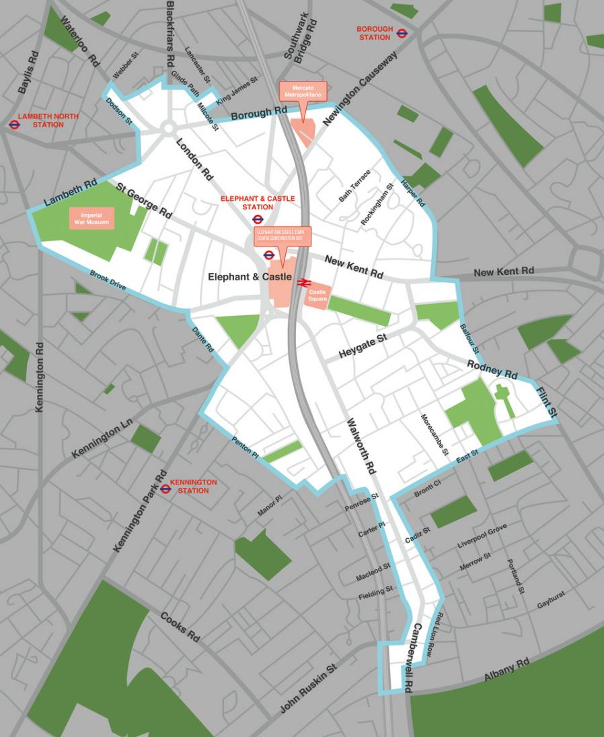

Supporting Documents
To support your application, you must attach relevant documents to your online application. Alternatively, you can also send these documents by email to diana.barranco@elephantandcastletowncentre.co.uk.

Please ensure you have the following documents ready to attach to your online application:
- Constitution or articles of association (the governing document of your organisation)
- Annual accounts or a record of income and expenditure for the applicant organisation for the most recent financial year
- One bank statement dated within the last 3 months in the organisation’s name that shows the account name, sort code and account number
- Safeguarding Policy for vulnerable adults and/or children and young people
- Equality & Diversity Policy*

* Get Living is committed to equality and diversity for all, and we expect groups and organisations applying for grants to show that they are aware of equality and diversity and can demonstrate commitment to them. Accordingly, organisations applying for grants are required to submit their Equality and Diversity policy with their application.

What We Will Fund
You can apply for funding to cover project activities and staffing, running costs related to the delivery of the project as well as the purchase of equipment you may need. All budgeted items must relate directly to the delivery of the proposed project.

What We Won’t Fund
The Inspiring Elephant Community Fund will not fund:

- Grants to individuals
- Expenditure or activities that have already taken place
- Services which are a statutory responsibility (i.e. are the responsibility of the Council, Government or Health Authorities)
- Religious or political activities (we are able to fund religious organisations if they are providing benefits for the wider community)
- Projects that have no community or charitable element
- Projects that take place outside of the Elephant & Castle Town Centre area
- Foreign travel

How to Apply
To apply for a grant of up to £5,000 please click here for the online application form

Application deadline: 5pm on Thursday 27th March 2025

Accessibility
If you have any questions on the Community Fund or would like support with your application please contact Diana on diana.barranco@elephantandcastletowncentre.co.uk. Paper application forms (and a version in Microsoft Word) is also available and can be provided on request.

Timetable
The Inspiring Elephant Community Fund is open for applications from Wednesday, 29th January 2025.

You can apply at any time, but you must submit your application by the deadline at 5pm on Thursday 27th March 2025.

We will notify you of the outcome of your application after the grants panel has met to consider all submitted eligible requests. This notification is usually 8 to 10 weeks after the deadline. Therefore, please consider this in your project planning and know that applicants will not be notified of funding decisions before mid-May 2025.

Grant Review Period
Please expect a potential phone call or email from an Inspiring Elephant Community Fund grant assessor the weeks following the grant deadline (end of March/April 2025), who may reach out for further details or clarification on your application prior to the grants panel meeting in May.

Project Monitoring
If your application is successful, you must be able to spend the money on your project within 12-months of the grant being awarded and complete an online end of grant report. You will be sent an end of grant report template via email 60 days prior to the completion of your project. You can request this report link sooner if you would like to gather your reporting information earlier on.

You will need to keep and provide the following;
- Financial records of how the grant is spent, including receipts and invoices
- Records and evidence of the identified outputs e.g. number of people benefiting, number of sessions, records of attendance etc.
- Records of the identified outcomes e.g. the difference the project has made to participants, participant feedback, staff observations, external reports from partners
- Photographs of the project activities (if appropriate)
- A case story from one participant including quotes of how the project has supported them

These pieces of information above must be submitted with the end of grant report. It is important to also gather information throughout the duration of your activities. The end of grant report will ask questions on your project, so please do consider the following to report back on:

- The activities you carried out with the funding
- Number of direct beneficiaries
- Impact numbers (such as how many people learned new skills, reported increased wellbeing, were connected to an advice service, etc.) that relate to your project, based on the outcomes you identified in your application
- Learnings or challenges experienced throughout project delivery
- Any significant changes from participants and a participant story/quote

If you have any questions on monitoring requirements on projects awarded funding, please contact Diana at diana.barranco@elephantandcastletowncentre.co.uk
The contribution of the Inspiring Elephant Community Fund must be acknowledged in any promotional literature or annual report issued on your behalf within twelve months of receiving the grant or any instalment of the grant. We reserve the right to use any photographs or details of the project in any future literature and/or promotion.

